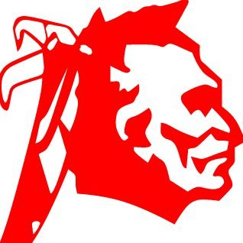
David Santana
Candidate for Seneca Nation Tribal Council
One Nation. Every Voice. A Stronger Tomorrow.

A Message to Seneca Party Members and Voters
Dear Seneca Party Members and Voters,
I hope you're doing well.
My name is David Santana, and I'm running for Seneca Nation Tribal Council because I believe every Seneca voice deserves to be heard.
As Seneca Party members and voters, we share an important responsibility in choosing the leadership that will move our Nation forward.
I am asking for your support and participation in this September's Seneca Party Caucus.
The decisions our Nation makes today affect all of us—our children, our Elders, our healthcare, education, housing, and the future of our communities. Whether you live on territory or off territory, your voice matters just as much as anyone else's.
I'm not asking for your vote simply because my name is on the ballot. I'm asking you to get involved because our Nation is stronger when more of our people participate.
If I'm fortunate enough to earn your support, here's what you can expect from me:
- I'll always be accessible and willing to listen.
- I'll work to improve communication between Tribal Council and our members.
- I'll continue advocating for quality healthcare, educational opportunities, and fair access to services for every enrolled Seneca.
- I'll work to make sure every member feels connected to our Nation, no matter where they call home.
I hope you'll take a few minutes to participate in the Seneca Party Caucus this September and, if I'm honored to earn the nomination, in the Seneca Nation General Election in November.
Please stay connected by following my Facebook campaign page, where I'll post meeting dates, campaign updates, important caucus information, and transportation details for anyone who may need assistance getting to the September caucus.
My goal is simple: to make sure every eligible Seneca voter has the opportunity to have their voice heard.
Whether you decide to support me or another candidate, I sincerely hope you'll take part in this election. Our Nation is strongest when more of us get involved, share our ideas, and help shape our future together.
Thank you for taking the time to read this. If you ever have a question, a concern, or simply want to talk, please don't hesitate to reach out. I'd be honored to hear from you.
Nya:wëh (Thank you),
David Santana
Candidate for Seneca Nation Tribal Council
Follow my Facebook campaign page for meeting updates, campaign announcements, September caucus information, and transportation updates.
One Nation. Every Voice. A Stronger Tomorrow.
Your Voice Matters. Your Vote Matters. Together, We Build Our Nation.

